

DSA05 – Query Processing for Data Science
LIST OF EXPERIMENTS

- Write a Pandas program to select the distinct department id from employees file.

+---------------+----------------------+------------+-------------+
| DEPARTMENT_ID | DEPARTMENT_NAME | MANAGER_ID | LOCATION_ID |
+---------------+----------------------+------------+-------------+
| 10 | Administration | 200 | 1700 |
| 20 | Marketing | 201 | 1800 |
| 30 | Purchasing | 114 | 1700 |
| 40 | Human Resources | 203 | 2400 |
| 50 | Shipping | 121 | 1500 |
| 60 | IT | 103 | 1400 |
| 70 | Public Relations | 204 | 2700 |
| 80 | Sales | 145 | 2500 |
| 90 | Executive | 100 | 1700 |
| 100 | Finance | 108 | 1700 |
| 110 | Accounting | 205 | 1700 |
| 120 | Treasury | 0 | 1700 |
| 130 | Corporate Tax | 0 | 1700 |
| 140 | Control And Credit | 0 | 1700 |
| 150 | Shareholder Services | 0 | 1700 |
| 160 | Benefits | 0 | 1700 |
| 170 | Manufacturing | 0 | 1700 |
| 180 | Construction | 0 | 1700 |
| 190 | Contracting | 0 | 1700 |
| 200 | Operations | 0 | 1700 |
| 210 | IT Support | 0 | 1700 |
| 220 | NOC | 0 | 1700 |
| 230 | IT Helpdesk | 0 | 1700 |
| 240 | Government Sales | 0 | 1700 |
| 250 | Retail Sales | 0 | 1700 |
| 260 | Recruiting | 0 | 1700 |
| 270 | Payroll | 0 | 1700 |
+---------------+----------------------+------------+-------------

- Write a Pandas program to display the IDs of employees who have done two or more jobs in the past.
+-------------+------------+------------+------------+---------------+
| EMPLOYEE_ID | START_DATE | END_DATE | JOB_ID | DEPARTMENT_ID |
+-------------+------------+------------+------------+---------------+
| 102 | 2001-01-13 | 2006-07-24 | IT_PROG | 60 |
| 101 | 1997-09-21 | 2001-10-27 | AC_ACCOUNT | 110 |
| 101 | 2001-10-28 | 2005-03-15 | AC_MGR | 110 |
| 201 | 2004-02-17 | 2007-12-19 | MK_REP | 20 |
| 114 | 2006-03-24 | 2007-12-31 | ST_CLERK | 50 |
| 122 | 2007-01-01 | 2007-12-31 | ST_CLERK | 50 |
| 200 | 1995-09-17 | 2001-06-17 | AD_ASST | 90 |
| 176 | 2006-03-24 | 2006-12-31 | SA_REP | 80 |
| 176 | 2007-01-01 | 2007-12-31 | SA_MAN | 80 |
| 200 | 2002-07-01 | 2006-12-31 | AC_ACCOUNT | 90 |
+-------------+------------+------------+------------+---------------+

- Write a Pandas program to display the details of jobs in descending sequence on job title.
+------------+---------------------------------+------------+------------+
| JOB_ID | JOB_TITLE | MIN_SALARY | MAX_SALARY |
+------------+---------------------------------+------------+------------+
| AD_PRES | President | 20080 | 40000 |
| AD_VP | Administration Vice President | 15000 | 30000 |
| AD_ASST | Administration Assistant | 3000 | 6000 |
| FI_MGR | Finance Manager | 8200 | 16000 |
| FI_ACCOUNT | Accountant | 4200 | 9000 |
| AC_MGR | Accounting Manager | 8200 | 16000 |
| AC_ACCOUNT | Public Accountant | 4200 | 9000 |
| SA_MAN | Sales Manager | 10000 | 20080 |
| SA_REP | Sales Representative | 6000 | 12008 |
| PU_MAN | Purchasing Manager | 8000 | 15000 |
| PU_CLERK | Purchasing Clerk | 2500 | 5500 |
| ST_MAN | Stock Manager | 5500 | 8500 |
| ST_CLERK | Stock Clerk | 2008 | 5000 |
| SH_CLERK | Shipping Clerk | 2500 | 5500 |
| IT_PROG | Programmer | 4000 | 10000 |
| MK_MAN | Marketing Manager | 9000 | 15000 |
| MK_REP | Marketing Representative | 4000 | 9000 |
| HR_REP | Human Resources Representative | 4000 | 9000 |
| PR_REP | Public Relations Representative | 4500 | 10500 |
+------------+---------------------------------+------------+------------+

- Write a Pandas program to create a line plot of the historical stock prices of Alphabet Inc. between two specific dates.

- Write a Pandas program to create a bar plot of the trading volume of Alphabet Inc. stock between two specific dates.

- Write a Pandas program to create a scatter plot of the trading volume/stock prices of Alphabet Inc. stock between two specific dates.
alphabet_stock_data:

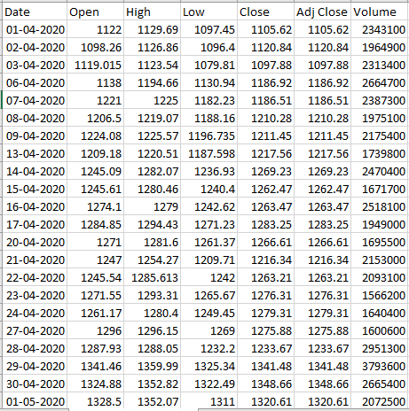
- Write a Pandas program to create a Pivot table and find the maximum and minimum sale value of the items.(refer sales_data table)
- Write a Pandas program to create a Pivot table and find the item wise unit sold. .(refer sales_data table)
- Write a Pandas program to create a Pivot table and find the total sale amount region wise, manager wise, sales man wise. .(refer sales_data table)
Sales_data:
OrderDate | Region | Manager | SalesMan | Item | Units | Unit_price | Sale_amt
1-6-18 | East | Martha | Alexander | Television | 95 | 1,198.00 | 1,13,810.00
1-23-18 | Central | Hermann | Shelli | Home Theater | 50 | 500.00 | 25,000.00
2-9-18 | Central | Hermann | Luis | Television | 36 | 1,198.00 | 43,128.00
2-26-18 | Central | Timothy | David | Cell Phone | 27 | 225.00 | 6,075.00
3-15-18 | West | Timothy | Stephen | Television | 56 | 1,198.00 | 67,088.00
4-1-18 | East | Martha | Alexander | Home Theater | 60 | 500.00 | 30,000.00
4-18-18 | Central | Martha | Steven | Television | 75 | 1,198.00 | 89,850.00
5-5-18 | Central | Hermann | Luis | Television | 90 | 1,198.00 | 1,07,820.00
5-22-18 | West | Douglas | Michael | Television | 32 | 1,198.00 | 38,336.00
6-8-18 | East | Martha | Alexander | Home Theater | 60 | 500.00 | 30,000.00
6-25-18 | Central | Hermann | Sigal | Television | 90 | 1,198.00 | 1,07,820.00
7-12-18 | East | Martha | Diana | Home Theater | 29 | 500.00 | 14,500.00
7-29-18 | East | Douglas | Karen | Home Theater | 81 | 500.00 | 40,500.00
8-15-18 | East | Martha | Alexander | Television | 35 | 1,198.00 | 41,930.00
9-1-18 | Central | Douglas | John | Desk | 2 | 125.00 | 250.00
9-18-18 | East | Martha | Alexander | Video Games | 16 | 58.50 | 936.00
10-5-18 | Central | Hermann | Sigal | Home Theater | 28 | 500.00 | 14,000.00
10-22-18 | East | Martha | Alexander | Cell Phone | 64 | 225.00 | 14,400.00

10.Create a dataframe of ten rows, four columns with random values. Write a Pandas program to highlight the negative numbers red and positive numbers black.
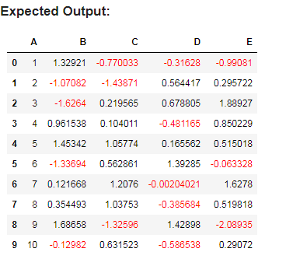
11.Create a dataframe of ten rows, four columns with random values. Convert some values to nan values. Write a Pandas program which will highlight the nan values.
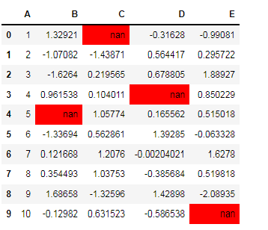

12.Create a dataframe of ten rows, four columns with random values. Write a Pandas program to set dataframe background Color black and font color yellow.
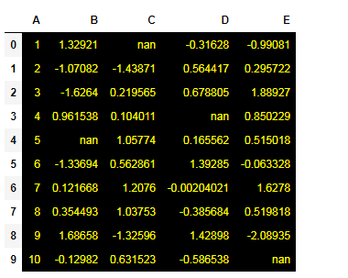

13.Write a Pandas program to detect missing values of a given DataFrame. Display True or False.
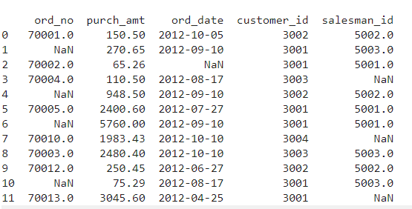

14. Write a Pandas program to find and replace the missing values in a given DataFrame which do not have any valuable information.
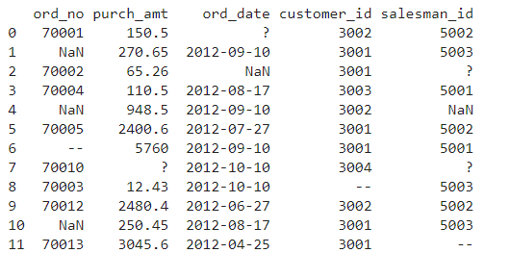

15.Write a Pandas program to keep the rows with at least 2 NaN values in a given DataFrame.
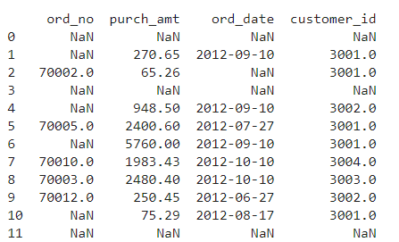

16.Write a Pandas program to split the following dataframe into groups based on school code. Also check the type of GroupBy object.
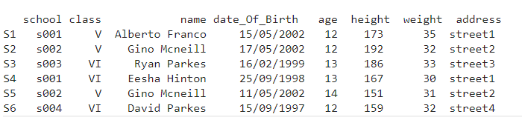
17.Write a Pandas program to split the following dataframe by school code and get mean, min, and max value of age for each school.
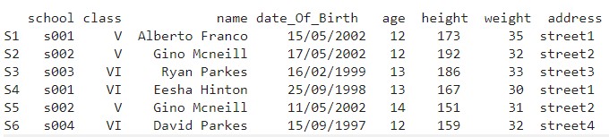
18.Write a Pandas program to split the following given dataframe into groups based on school code and class.
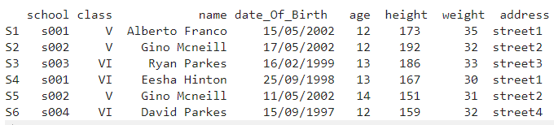
19.Write a Pandas program to display the dimensions or shape of the World alcohol consumption dataset. Also extract the column names from the dataset.
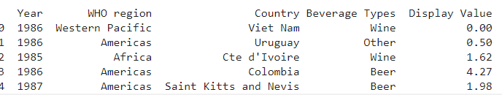

20.Write a Pandas program to find the index of a given substring of a DataFrame column.

21.Write a Pandas program to swap the cases of a specified character column in a given DataFrame.

22.Write a Python program to draw a line with suitable label in the x axis, y axis and a title.

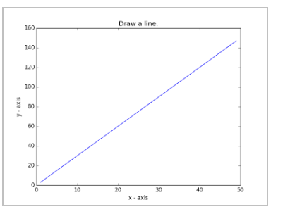
23.Write a Python program to draw a line using given axis values taken from a text file, with suitable label in the x axis, y axis and a title.
Test Data:
test.txt
1 2
2 4
3 1
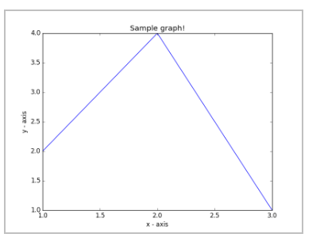
24.Write a Python program to draw line charts of the financial data of Alphabet Inc. between October 3, 2016 to October 7, 2016.
Sample Financial data (fdata.csv):
Date,Open,High,Low,Close
10-03-16,774.25,776.065002,769.5,772.559998
10-04-16,776.030029,778.710022,772.890015,776.429993
10-05-16,779.309998,782.070007,775.650024,776.469971
10-06-16,779,780.47998,775.539978,776.859985
10-07-16,779.659973,779.659973,770.75,775.080017
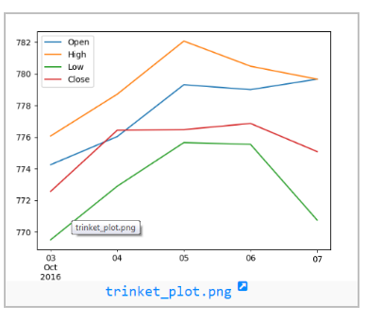

25.Write a Python program to plot two or more lines with legends, different widths and colors.
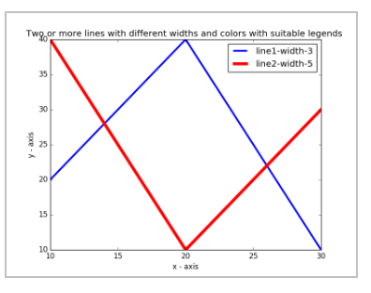
26.Write a Python program to create multiple plots.

27.Write a Python programming to display a bar chart of the popularity of programming Languages.
Sample data:
Programming languages: Java, Python, PHP, JavaScript, C#, C++
Popularity: 22.2, 17.6, 8.8, 8, 7.7, 6.7
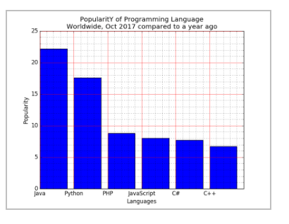
28.Write a Python programming to display a horizontal bar chart of the popularity of programming Languages.
Sample data:
Programming languages: Java, Python, PHP, JavaScript, C#, C++
Popularity: 22.2, 17.6, 8.8, 8, 7.7, 6.7
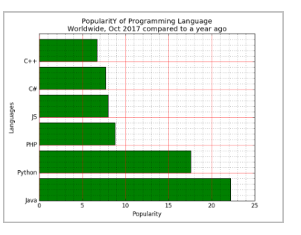
29.Write a Python programming to display a bar chart of the popularity of programming Languages. Use different color for each bar.
Sample data:
Programming languages: Java, Python, PHP, JavaScript, C#, C++
Popularity: 22.2, 17.6, 8.8, 8, 7.7, 6.7
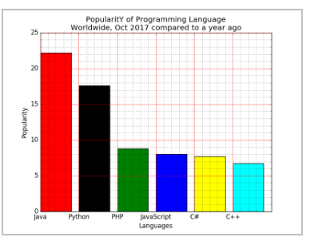
30.Write a Python program to create bar plot of scores by group and gender. Use multiple X values on the same chart for men and women.
Sample Data:
Means (men) = (22, 30, 35, 35, 26)
Means (women) = (25, 32, 30, 35, 29)
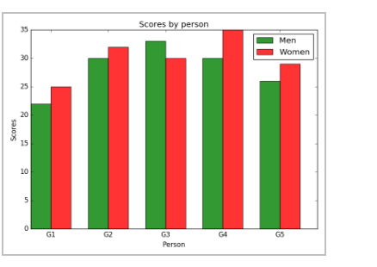
31.Write a Python program to create a stacked bar plot with error bars.
Note: Use bottom to stack the women?s bars on top of the men?s bars.
Sample Data:
Means (men) = (22, 30, 35, 35, 26)
Means (women) = (25, 32, 30, 35, 29)
Men Standard deviation = (4, 3, 4, 1, 5)
Women Standard deviation = (3, 5, 2, 3, 3)
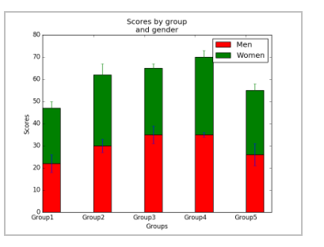

32.Write a Python program to draw a scatter graph taking a random distribution in X and Y and plotted against each other.
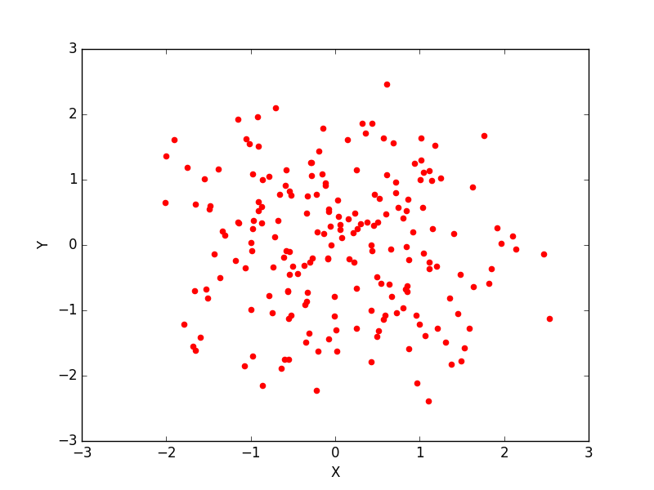
33.Write a Python program to draw a scatter plot with empty circles taking a random distribution in X and Y and plotted against each other.
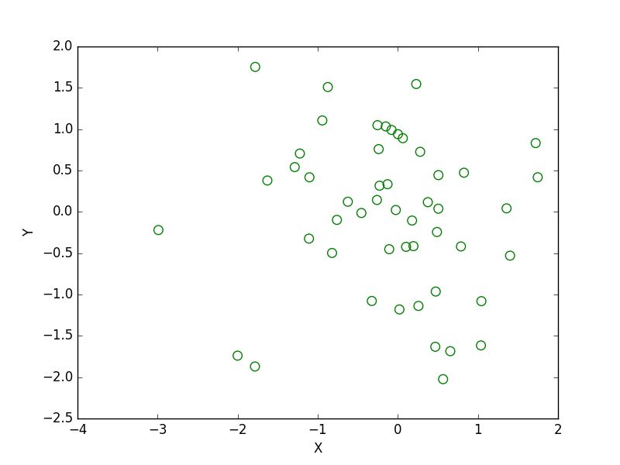
34.Write a Python program to draw a scatter plot using random distributions to generate balls of different sizes.
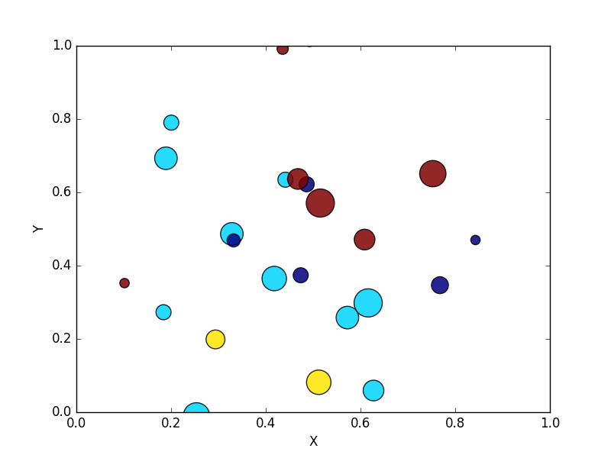
35.Write a Python program to draw a scatter plot comparing two subject marks of Mathematics and Science. Use marks of 10 students.
Sample data:
Test Data:
math_marks = [88, 92, 80, 89, 100, 80, 60, 100, 80, 34]
science_marks = [35, 79, 79, 48, 100, 88, 32, 45, 20, 30]
marks_range = [10, 20, 30, 40, 50, 60, 70, 80, 90, 100]
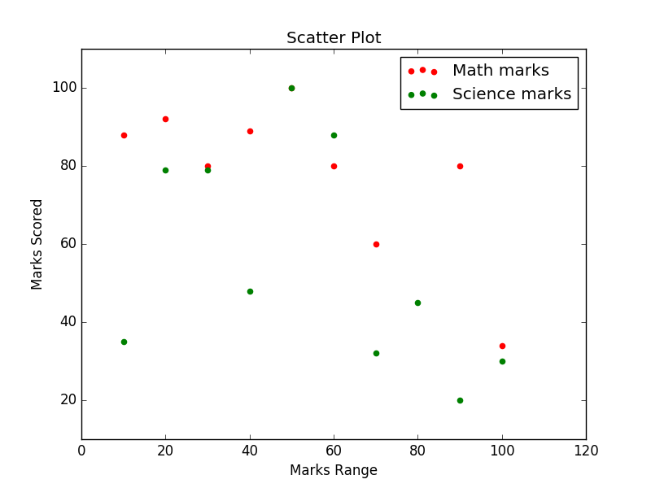
36.Write a Python program to draw a scatter plot for three different groups comparing weights and heights.
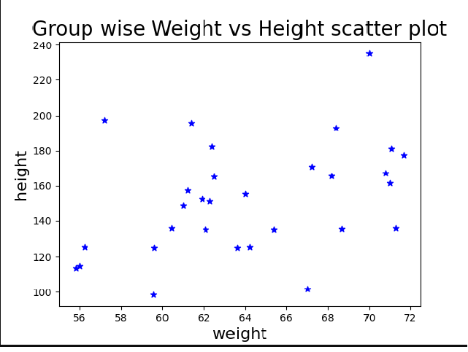
37.Write a Pandas program to create a dataframe from a dictionary and display it.
Sample data: {'X':[78,85,96,80,86], 'Y':[84,94,89,83,86],'Z':[86,97,96,72,83]}
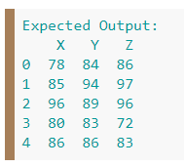
38.Write a Pandas program to create and display a DataFrame from a specified dictionary data which has the index labels.
Sample Python dictionary data and list labels:
exam_data = {'name': ['Anastasia', 'Dima', 'Katherine', 'James', 'Emily', 'Michael', 'Matthew', 'Laura', 'Kevin', 'Jonas'],
'score': [12.5, 9, 16.5, np.nan, 9, 20, 14.5, np.nan, 8, 19],
'attempts': [1, 3, 2, 3, 2, 3, 1, 1, 2, 1],
'qualify': ['yes', 'no', 'yes', 'no', 'no', 'yes', 'yes', 'no', 'no', 'yes']}
labels = ['a', 'b', 'c', 'd', 'e', 'f', 'g', 'h', 'i', 'j']
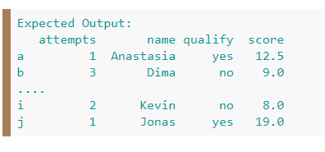
39.Write a Pandas program to get the first 3 rows of a given DataFrame.
Sample Python dictionary data and list labels:
exam_data = {'name': ['Anastasia', 'Dima', 'Katherine', 'James', 'Emily', 'Michael', 'Matthew', 'Laura', 'Kevin', 'Jonas'],
'score': [12.5, 9, 16.5, np.nan, 9, 20, 14.5, np.nan, 8, 19],
'attempts': [1, 3, 2, 3, 2, 3, 1, 1, 2, 1],
'qualify': ['yes', 'no', 'yes', 'no', 'no', 'yes', 'yes', 'no', 'no', 'yes']}
labels = ['a', 'b', 'c', 'd', 'e', 'f', 'g', 'h', 'i', 'j']
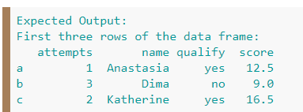
- Write a Pandas program to select the 'name' and 'score' columns from the following DataFrame.
Sample Python dictionary data and list labels:
exam_data = {'name': ['Anastasia', 'Dima', 'Katherine', 'James', 'Emily', 'Michael', 'Matthew', 'Laura', 'Kevin', 'Jonas'],
'score': [12.5, 9, 16.5, np.nan, 9, 20, 14.5, np.nan, 8, 19],
'attempts': [1, 3, 2, 3, 2, 3, 1, 1, 2, 1],
'qualify': ['yes', 'no', 'yes', 'no', 'no', 'yes', 'yes', 'no', 'no', 'yes']}
labels = ['a', 'b', 'c', 'd', 'e', 'f', 'g', 'h', 'i', 'j']
